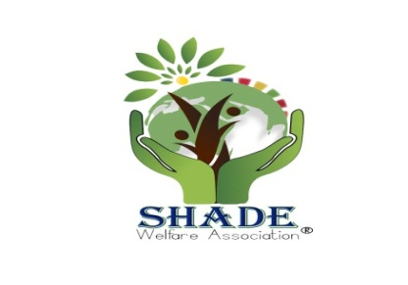

®
Your help can change the lives!

Address: - A-11 Professor housing Society, Site Area Square, Sukkur, Sindh, Pakistan.
E-mail: - shade.sindh@gmail.com, website:-www.shadpak.weebly.com, Phone: +92 -315-2205201

Form No _______

1.Name | Click here to enter text.
2.Father Name | Click here to enter text.
3.Sex: | Male / Female
4.C.N.I.C | Click here to enter text. |  | 5.Nationality | Click here to enter text.
6.Province | Click here to enter text. |  | 7.District | Click here to enter text.
8.City | Click here to enter text. | 9.Occupation: | Student / Profession( )
10.Qualification | Click here to enter text. |  | 11.Experties: |  | Click here to enter text.
12.Phone Home | Click here to enter text. |  | 13.Phone Office: |  | Click here to enter text.
14.Cell No. | Click here to enter text. |  | 14.Email ID: |  | Click here to enter text.
15.Address | Click here to enter text.
16.Purpose (If any) | Click here to enter text.
17. Nature of Membership | Life Member / Ordinary Member / Regular Member

18. I am willing to become a member of Shade welfare Association (S.W.A) and I agree to abide by the policies of Shade welfare Association.

Date ________________ Signature of Member________________

As Decided By General Body Meeting Held in 2018 in Sukkur.

Life Member Ship 5000/= (Subject to approval from Executive Body)

Ordinary Member 1,500/= (Per year)

Regular Member 600/= (per 6 month or 100 per month)
What is Shade?

Shade Welfare Association® (SWA) is registered, an independent, grassroots, non-profit, non-political & non-governmental organization, which has been working for the Health education, women and child protection, Community Development socio-economic empowerment of the poor people through the implementation of different development programs in the area. This organization came into being with determination, commitment, and dedication by the group of energetic people of both sexes in 2009. The organization registered under Social Welfare voluntary Organization Act: 1961 with Directorate of Social Welfare / Community Development Department Government of Sind, Pakistan.

AIM AND OBJECTIVE:
Shade is entirely dedicated to humanitarian services. We ought and willing to work for:

- Child Protection
- Woman Protection
- Basic Education
- Basic Health
- Communities Development
- Work for Poor and needy persons.

Shade welfare is woolly dedicated to humanitarian services. We are officially Register under Voluntary Social Welfare Agency Act 1961 Pakistan .the Area of work is Sukkur district. Our registration no is DO-SW-(SUK)-V.A/-XVAXX-69. We work for child protection, women protection, basic education, and health and communities development.

NB
Our Organization appreciates your interest in working with us; we are looking forward to your service for the betterment of our Community and its posterity. However, the organization will not be held responsible for anything that happens to you while offering your Member/volunteer services to it:

Shade Official Signature

